COMP5310 – Principles of Data Science
Project Stage 1 — Explore, Clean, Summarize and Analyze
Dataset A: Hotel Booking

Field | Details
Group Number | Lab014_Group_04
SID | 550615055
UniKey | isar0627
Submission Date | 5 April 2026
Unit | COMP5310 – Principles of Data Science
University | The University of Sydney

Dataset C: Hotel Booking

Step 1. Problem Definition

1.1 Business Problem
Hotel chains/ owners manage thousands of reservations across the city and resort properties. The main challenge faced by the operations and financial team is to know whether the customer will cancel their booking before arriving. This analysis defines the following classification problem:
“Can we predict whether a hotel booking will be canceled before the guest’s arrival, using the information available at the time of booking?”

1.2 Stakeholders and Benefits

Stakeholder | Benefit from Solving the Problem
Hotel Finance Team | Use cancellation predictions to remove overbooking levels dynamically, rather than applying policies on booking cancelation.
Operation and Front of House Teams | More accurate arrival forecasts will help in planning staffing and room readiness
Online Travel Agencies | Can define better commission structure or insurance policy based on the knowledge at the time of booking
Guests | Benefits from fair pricing of rooms.

1.3 Problem Type
The target variable is is_canceled (1 = cancelled, 0 = not cancelled), making this a binary classification task. With a cancellation rate of approximately 37% observed in this dataset, the financial stakes are significant.

Step 2. Data Description

2.1 Dataset Overview
The NSW Train Occupancy dataset was loaded and inspected to understand its structure and content before any cleaning was applied to the dataset.

Property | Value
Total Rows (instances) | 119987
Total Columns (attributes) | 32
Missing Values | Present (dropped during cleaning)
Duplicate Rows | Present (removed during cleaning)

2.2 Data Types of Each Attribute

Booking Information
Feature | Type | Missing | Description
hotel | string | 0% | Hotel type — City Hotel or Resort Hotel
is_canceled | int | 0% | Target variable — 1 if cancelled, 0 not cancelled
lead_time | int | 0% | Days between booking date and arrival date
booking_changes | int | 0% | Number of changes made before check-in
deposit_type | string | 0% | Deposit policy — No Deposit, Non Refund, Refundable
days_in_waiting_list | int | 0% | Days on waitlist before confirmation
reservation_status | string | 0% | Final status — Check-Out, Cancelled, No-Show (drop before modelling)
reservation_status_date | date | 0% | Date the reservation status was last set

Arrival Details
Feature | Type | Missing | Description
arrival_date_year | int | 0% | Year of arrival
arrival_date_month | string | 0% | Month of arrival — full name
arrival_date_week_number | int | 0% | Week number of arrival
arrival_date_day_of_month | int | 0% | Day of the month of arrival
stay_in_weekend_nights | Int | 0% | Number of weekend nights
stay_in_week_nights | Int | 0% | Number of weekday nights

Customer Characteristics
Feature | Type | Missing | Description
adults | int | 0% | Number of adults in the booking
children | float | 0.15% | Number of children stored as float, should be integer
babies | int | 0% | Number of babies in the booking
country | string | 0.52% | Guest country of origin
is_repeated_guest | int | 0% | 1 if guest has previously stayed at the hotel
previous_cancellations | int | 0% | Number of prior bookings the guest cancelled
previous_bookings_not_canceled | int | 0% | Number of prior bookings completed without cancelling
customer_type | string | 0.13% | Transient, Transient-Party, Contract, or Group

Market Segments
Feature | Type | Missing | Description
market_segment | string | 0.11% | Segment the booking came from
distribution_channel | string | 0.14% | Channel used to distribute the booking
agent | float | 13.79% | Travel agency ID
company | float | 94.31% | Company ID

Operational and Financial Indicator
Feature | Type | Missing | Description
meal | string | 0.12% | Meal plan chosen
reserved_room_type | string | 0% | Room type requested at booking
assigned_room_type | string | 0% | Room type actually assigned at check-in
required_car_parking_spaces | int | 0% | Number of parking spaces requested
total_of_special_requests | int | 0% | Total number of special requests made
adr | float | 0% | Average Daily Rate — total revenue ÷ total nights

2.3 Missing Values and Duplicates
During inspection of the data, company attribute was dropped as more than 90% of data was missing and duplicate rows were dropped, rest of the missing values were handled using 0 or unknown based on the attribute.

Issue | Finding | Action Taken
Missing Values | Majorly present in company columns | Company column is dropped and same missing values replaced with 0 or “Unknown”
Duplicate Rows | Duplicate entries detected | Removed

2.4 Unique Values in Categorical Features
Key categorical columns were inspected for unique values. This revealed data quality issues that are addressed in Step 3:
- Hotel: Data inconstancies were present ['City Hotel', 'Resort Hotel', 'ResortHotel', 'CityHotel'] converted to [‘City Hotel’, ‘Resort Hotel’].
- Arrival_Date_Month: Included the different month like January, February, December.
- Meal: Different meal plans were present [“BB”, “HB”, “SC”, “FB”, “Undefined”, “nan”]. Missing values(nan) were replaced with SC as it meant opted out of meal plan.
- Market_Segment: Included values like [“Online TA”, “Groups”, “Direct”, “Complementary”]
- Reserved_Room_Type: ['A', 'D', 'E', 'H', 'F', 'C', 'G', 'B', 'P', 'L']
- Deposit_Type: [“Refundable”, “Non-Refundable”, “No Deposit”]
- Customer_Type: [“Transient”, “Group”, “Contract”, “Transient-Party”]

Step 3. Data Cleaning and Processing

3.1 Issues Identified and Cleaning Strategies
The following data quality issues were identified and resolved using data cleaning strategies.

Issue | Column Affected | Cleaning Strategy | Justification
Missing values | Company, children, agent, country, meal, market_segment, customer_type, distribution_channel, | Dropped column Company  Filled missing values in numerical data with 0  Filled missing values in categorical data with “Unknown”. For meal filled missing data with “SC” considering guest opted out of meal | Since not much data was missing if was handled appropriately and company column was dropped as more than 90% data was missing.
Duplicate rows | Entire dataset | Removed using df.drop_duplicates() | Duplicates would skew frequency counts and introduce bias in EDA and modelling.
Inconsistent capitalization | Meal, market_segment, distribution_channel, customer_type, reservation_status | Standardised to uppercase. | Ensures consistent category labels for grouping and visualization.
Typographical error | Market_segment, | Replaced to correct value using replace() | Corrects the label to match the valid category.
Whitespace inconsistency and Trailing Whitespace | Hotel, meal, market_segment, customer_type | Removed spaces after some categories and some values needed space in between. | Trailing spaces values to appear as more distinct categories.

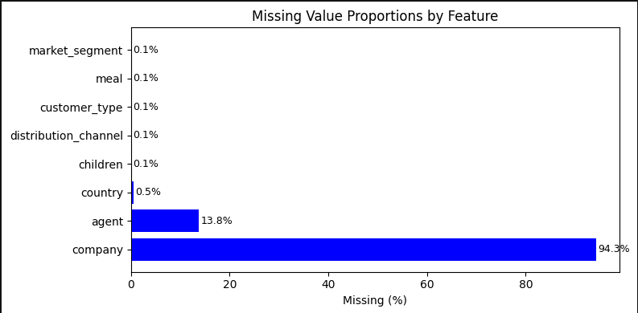
Figure 1: Missing values % graph.

Insight on missing and duplicate values: Upon thorough inspection of the dataset, the company column was dropped, rest of the missing values were filled with there related meanings like for numerical it was filled with 0 and for categorical we can take example of meal which was filled with SC.

3.2 Data After Cleaning
After applying all cleaning processes, the dataset of shape(74111, 31) was verified and saved as hotel_analysis_cleaned.csv. The final cleaned dataset had no missing values, no duplicate rows, and ready for EDA.

3.3 Feature Engineering

Three new features were created to help the model to better predict the cancelation of bookings:
Feature | Derived From | Method | Rationale
total_guests | Children, adults, babies | Children + adult + babies | Created to feed the model with total number of guests.
total_nights | stay_in_weekedn_nights,  stay_in_week_nights | Adding both the columns | Created to get the exact duration of stay
arrival_date | arrival_day_month, arrival_day_year,  arrival_date_day_of_monnth | Converted to  YYYY-MM-DD | Providing the information to the model what is the expected arrival date

Step 4. Exploratory Data Analysis
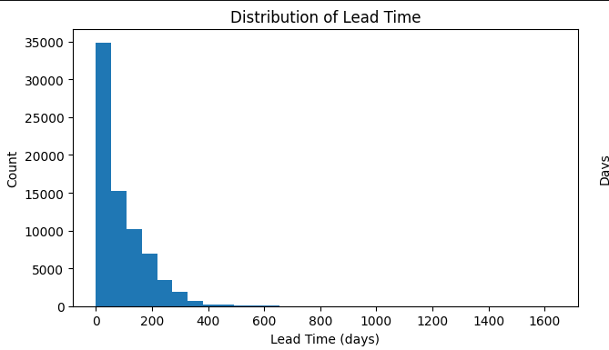
Figure 1: Distribution of Lead Time

From the above histogram we see that the lead time follows a strong right-skewed distribution, with the majority of bookings made within 0-100 days of arrival. The tallest bar (0-50 days) contains approximately 35,000 bookings from this can be interpreted that most guests book close to their arrival date.

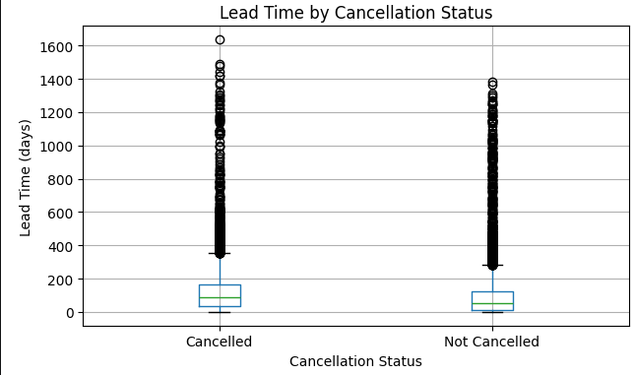
Figure 3: Lead Time by Cancellation Status
From the above figure we can interpretate that cancelled bookings have a noticeably higher median lead time and a wider IQR compared to bookings that were not cancelled. The median for cancelled bookings appears to be around 100–120 days, while not-cancelled bookings sit closer to 50–60 days.

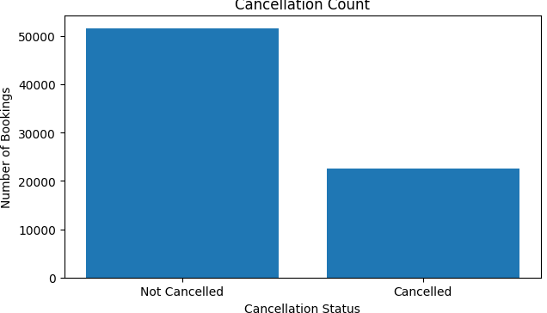

Figure 4: Cancellation Count Graph
The bar chart shows the class distribution of the target variable. Approximately 52,000 bookings were not cancelled compared to around 23,000 that were cancelled. Classes are imbalanced but the minority class is still substantial that normal models could learn from it.

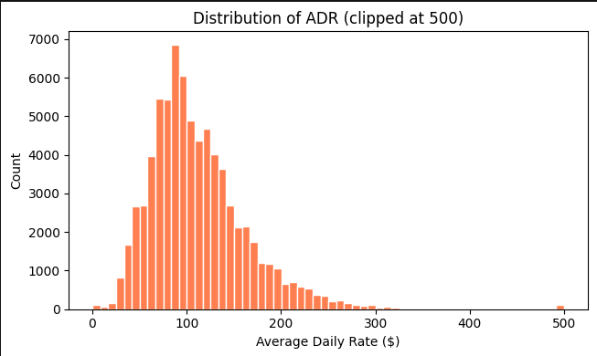

Figure 5: Distribution of ADR.

The above ADR distribution is approximately bell-shaped with a slight right skew. The majority of bookings fall within the $50–$200 range, with the peak occurring around $80–$100 per night.

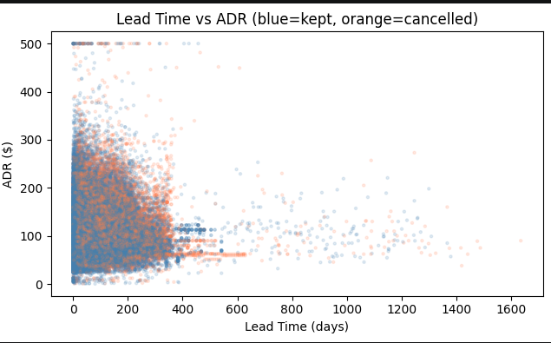

Figure 6: Lead Time vs ADR scatter plot

The above plot shows cancelled bookings as orange and kept bookings as which were not cancelled across the lead time and average daily room rate. The data is concentrated highly in the timespan of (0-300) days and ($0-$200). We can also see that there is no linear relationship between lead time and ADR. We see data scattered all around the graph and can say these two cannot determine the cancelation of bookings.

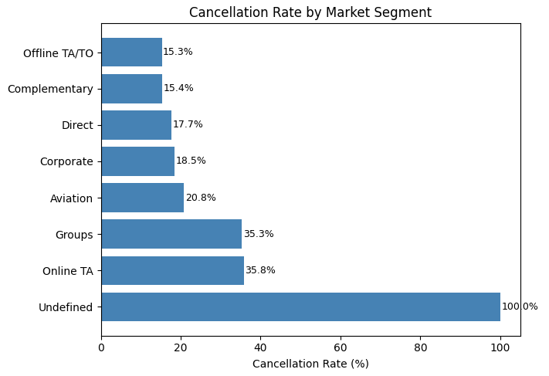

Figure 7: Cancelation Rate by Market Segment

The chart shows cancellation rates vary significantly across segments. Online TA (35.8%) and Groups (35.3%) have the highest rates, while Offline TA/TO (15.3%) and Direct (17.7%) have the lowest. The Undefined segment shows 100% a cancelation rate and will be addressed in further cleaning before modeling.

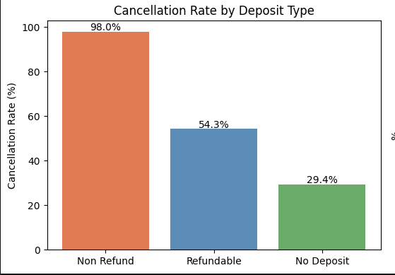

Figure 8: Cancelation of Deposit Time

From the above graph Non Refund deposits have the highest cancellation rate likely because the reservation status is recorded as cancelled even though the hotel retains the payment.

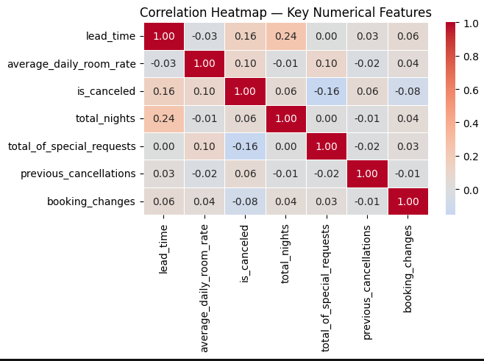

Figure 9: Correlation Matrix

From the correlation matrix above it can be derived that no variable in highly related to each other either positively or negatively. All variables are loosely coupled

AI ACKNOWLEDGMENT

I used Claude (Anthropic) from 28–31 March 2026 to assist with structuring the report layout and understanding how to phrase data insights and for some debugging. All code, data analysis, visualizations, cleaning decisions, and final written content are my own. I reviewed, paraphrased, and validated all AI-suggested content before inclusion in this report.

Tool used: Claude (Anthropic)

Dates used: 28–31 March 2026

How it was used: Assisted with report structure and rephrasing of insights.
My own contribution: All analysis, data cleaning, code, visualizations, and final conclusions are my own.

